Catholic Junior College
JC2 Preliminary Examination
Higher 1



Instruction

GEOGRAPHY 8834/01
INSERT 28 August 2026
3 hours

READ THESE INSTRUCTIONS FIRST
This Insert contains all the resources referred to in the questions.

This document consists of 9 printed pages and 1 blank page.
Resource 1 for Question 1
Map of Melbourne Central Business District (CBD)
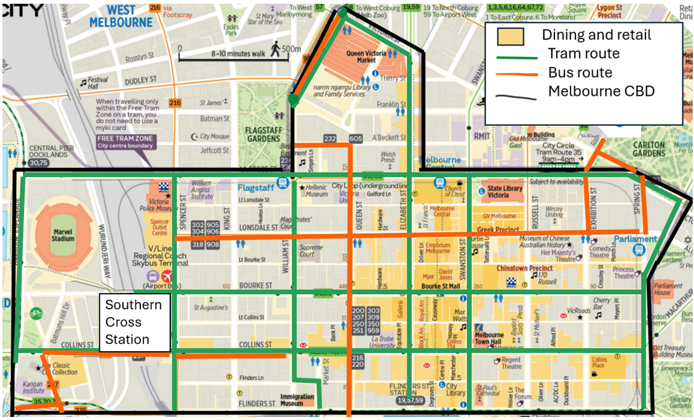

Resource 2 for Question 1
Photograph of Southern Cross Station
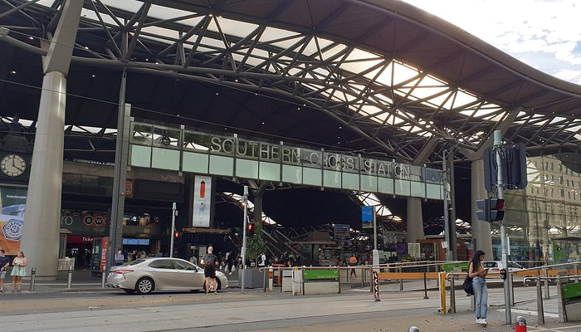

Photograph of interior of a tram
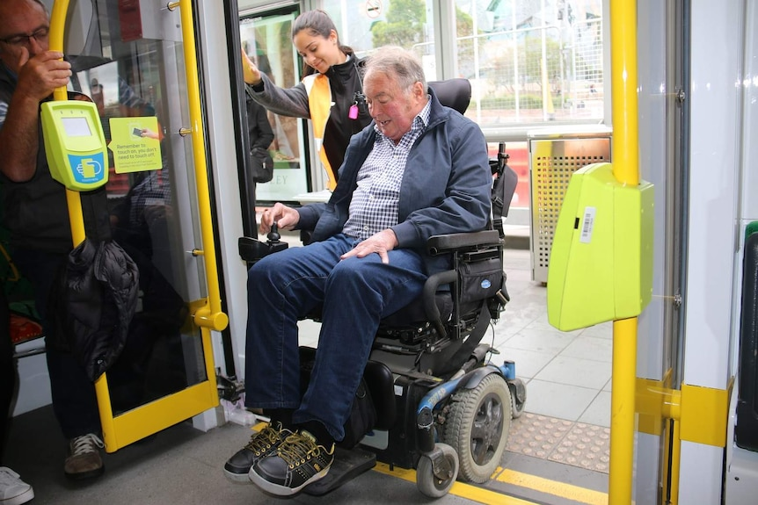

Resource 3 for Question 1

Questionnaire used by students for survey

Section A: Basic Information
1. Age: ______
2. Gender: ☐ Male ☐ Female ☐ Prefer not to say
3. How long have you lived in Melbourne?
☐ Less than 1 year ☐ 1–5 years ☐ 6–10 years ☐ More than 10 years

Section B: Accessibility
4. How often do you commute around Melbourne CBD?
☐ Always ☐ Most of the time ☐ Sometimes ☐ Rarely ☐ Never

5. Where do you usually visit?
________________________________________
6. How convenient is it for you to travel to work?
☐ Very convenient ☐ Convenient ☐ Inconvenient ☐ Very inconvenient
7. How convenient is it for you to access medical supplies?
☐ Very convenient ☐ Convenient ☐ Inconvenient ☐ Very inconvenient
8. How convenient is it for you to access food supplies?
☐ Very convenient ☐ Convenient ☐ Inconvenient ☐ Very inconvenient
9. How convenient is it for you access recreational activities and see the doctor?
☐ Very convenient ☐ Convenient ☐ Inconvenient ☐ Very inconvenient

Resource 4 for Question 1
Resource 4A
Profile of respondents
Question | Responses
Age range | 70–74 (50%)
Years lived in Melbourne | More than 10 years (45%)
Gender | Female (50%) and male (50%)

Resource 4B
Selected responses from survey
Question | Responses
How convenient is it for you to access medical supplies? | Convenient (45%) Inconvenient (27%) Very inconvenient (28%)
How convenient is it for you to access food supplies? | Convenient (83%) Very convenient (17%)
How convenient is it for you to access recreational activities and see the doctor? | Inconvenient (70%) Very inconvenient (30%)

Resource 4C
Selected results from observations
Tram number | Lighting | Reserved Seating for Elderly | Wheelchair access | Space
1 | Good | Yes | Present | Open
2 | Moderate | Yes | Not present | Cramped
3 | Poor | No | Not present | Cramped
4 | Good | Yes | Present | Open

Resource 5 for Question 2
Map showing changes in liveability rankings in Asia Pacific, from 2021 to 2022
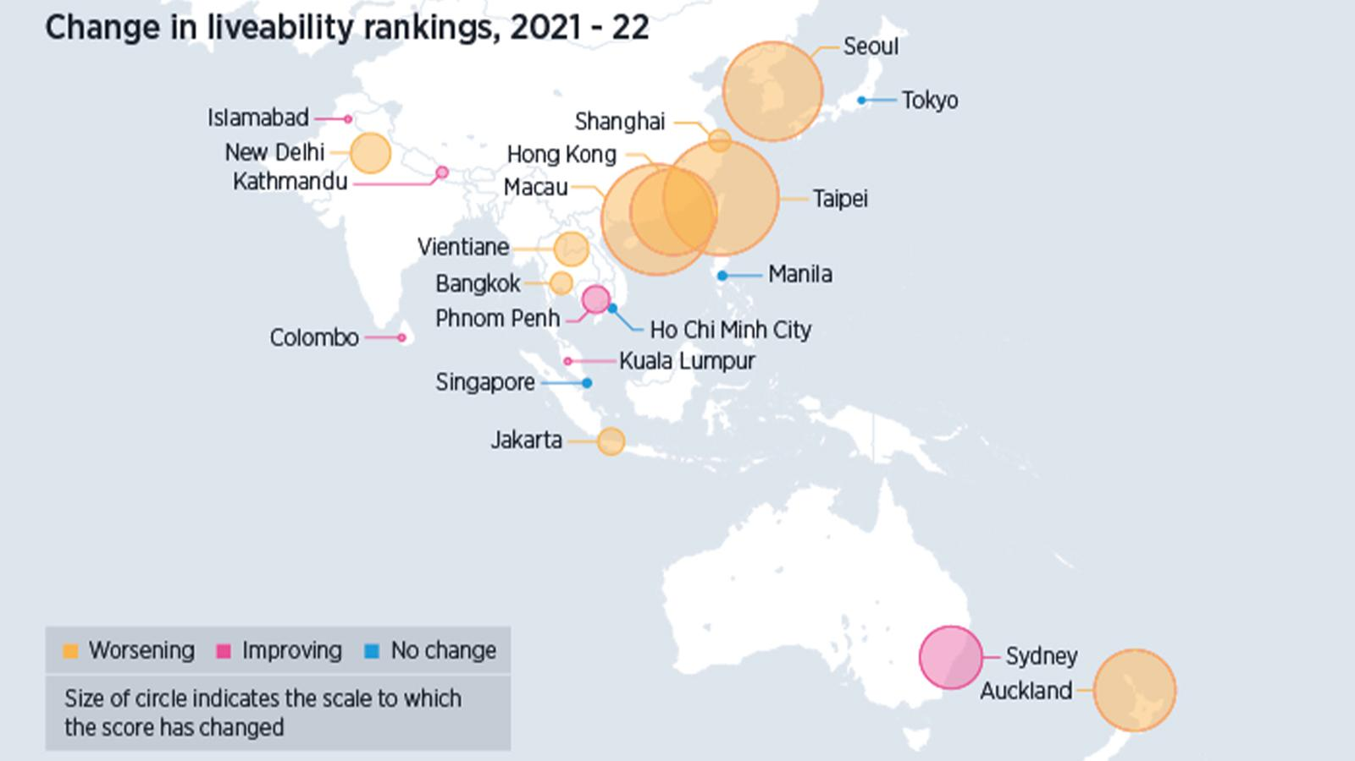

Resource 6 for Question 2
Types of green spaces and their uses in Bueno Aires, Argentina
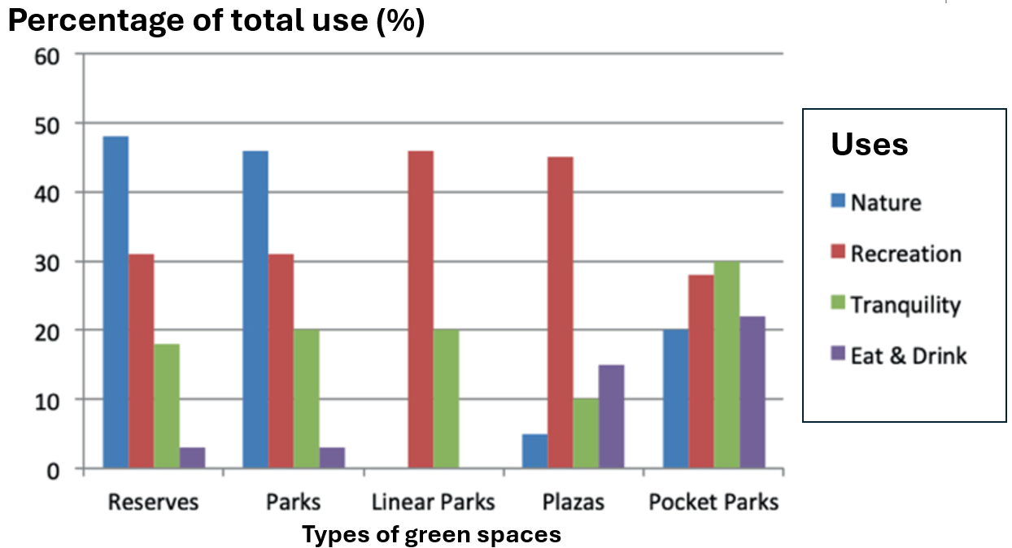

Resource 7 for Question 2
Reimagined street in New York City (before and after)
Before
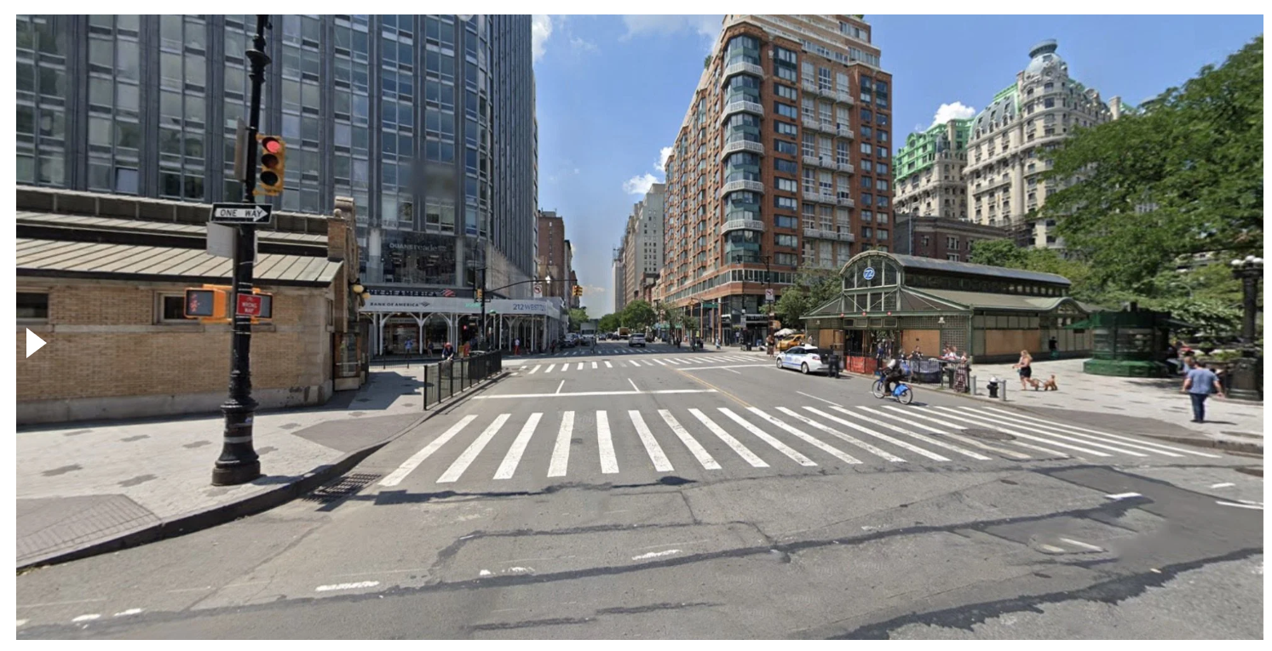

After
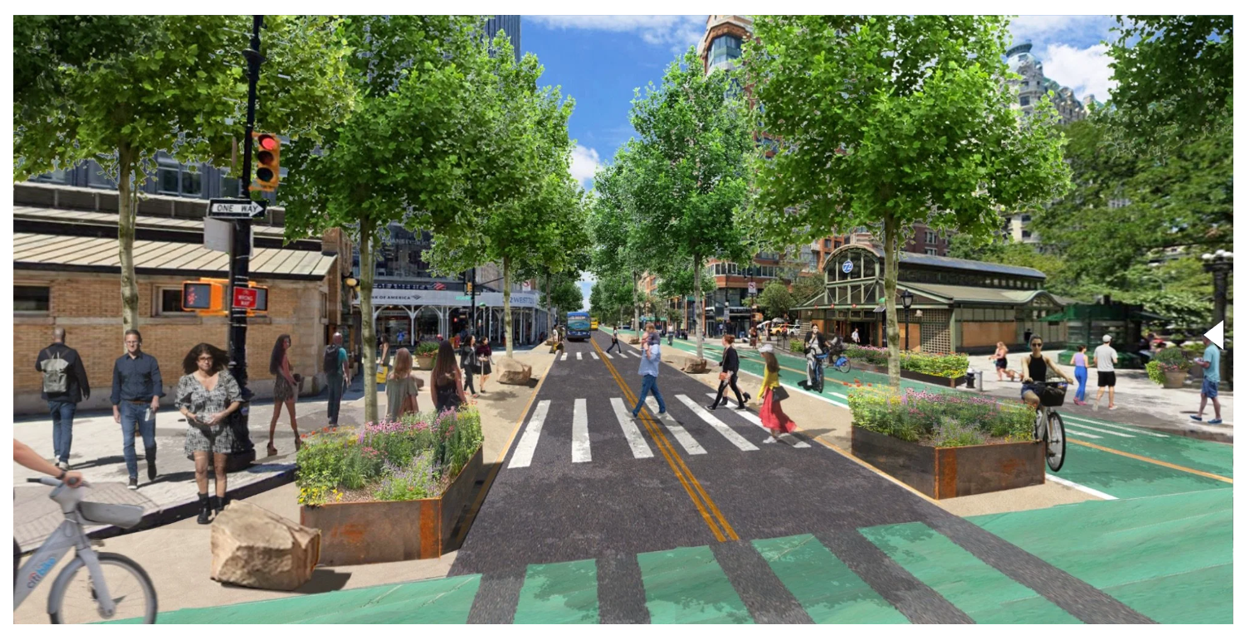

Resource 8 for Question 3
Impact of climate change on the world’s biggest economies in 2048
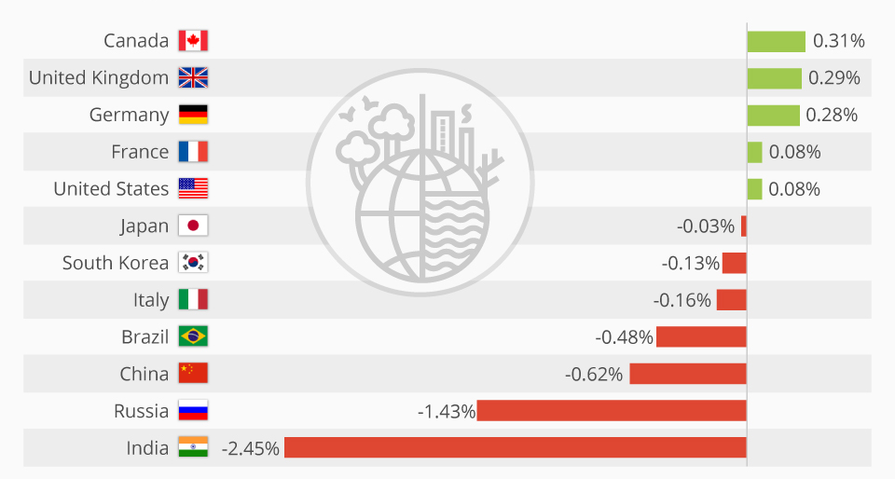

Resource 9 for Question 3
Climate protection performance of countries in 2023
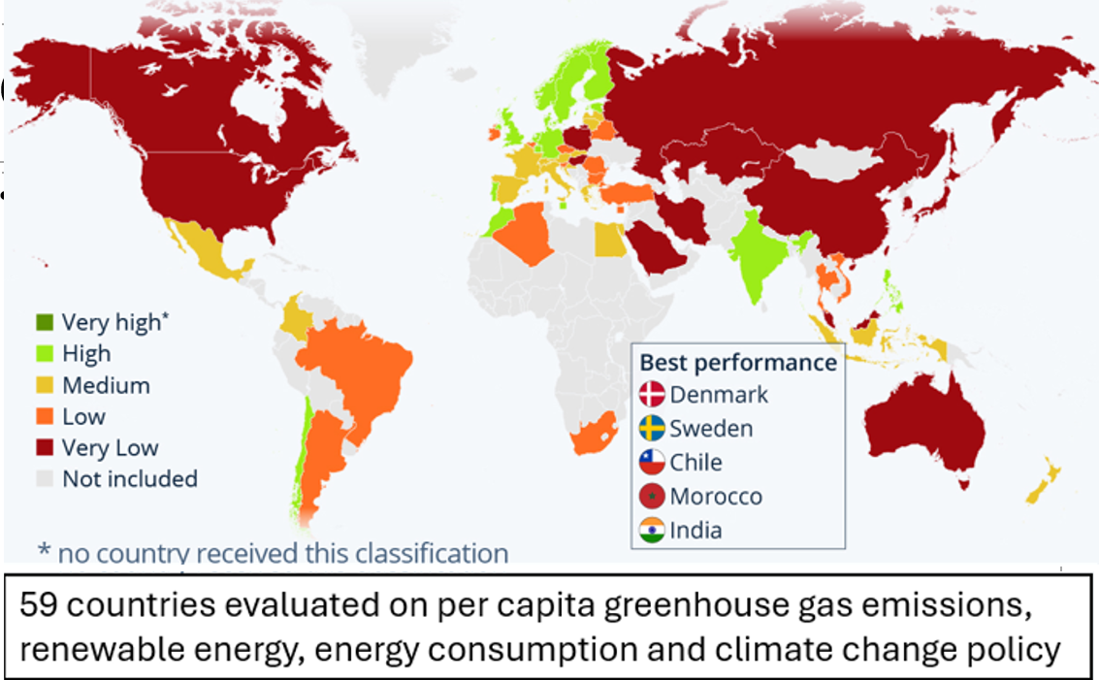

BLANK PAGE

Resources
Question 1 Resource 1 [Adapted from https://www.visitvictoria.com/features/cbd-map]
Question 1 Resource 2 [Source: https://www.tripadvisor.com.sg/Attraction_Review-g255100-d9811247-Reviews-Southern_Cross_Station-Melbourne_Victoria.html]
Question 1 Resource 2 [Source: Google Maps]
Question 2 Resource 5 [Source: https://www.humanresourcesonline.net/]
Question 2 Resource 6 [Source: Faggi, A., Breuste, J. (2023). Relationship Between Form and Structure of Green Spaces and Uses: The Case of Parks in Buenos Aires City, Argentina. In: Breuste, J., Artmann, M., Ioja, C., Qureshi, S. (eds) Making Green Cities. Cities and Nature. Springer, Cham.]
Question 2 Resource 7 [Source: https://www.streetopia.city/reimagining-w72]
Question 3 Resource 8 [Source: https://www.statista.com/chart/18610/estimated-impact-of-a-4c-temperature-increase-on-gdp/?srsltid=AfmBOoroQjhBpLa-WSKtA1N8YZxKWco77y43f3uEgMLyX81oREF9csMA]
Question 3 Resource 9 [Source: https://www.statista.com/chart/28816/climate-change-performance-index/?srsltid=AfmBOoqkUAylz2EHo20V96SuMqb87KS8c8xYnhvAhqCHB8rfhQ2TDiKk]

